7th Grade Integrated Science
Information and Expectations
Mrs. Tippetts
2016-2017

Course Objective: The 7th grade science program focuses on the theme of “structure” as it applies to physical, earth, and life sciences. It is designed to encourage students to use inquiry, critical thinking, and problem solving skills to better observe, appreciate, and understand the world around them.

Syllabus:
Nature of Science August 17 – September 30
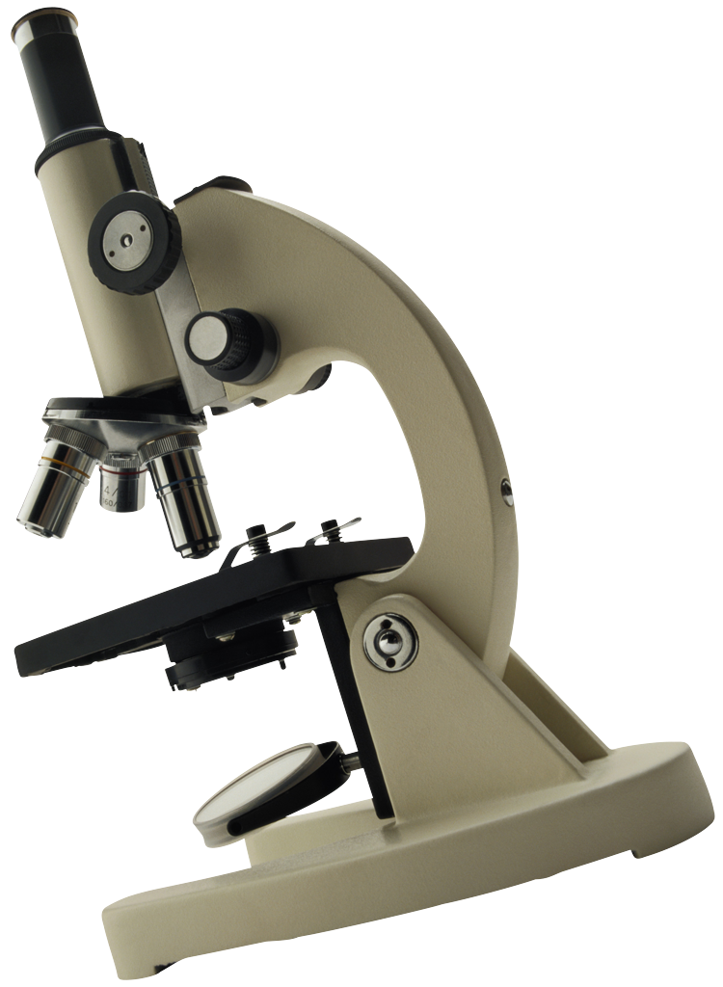
Atomic Motion and Interactions - November 11
Earth Structure (Christmas Break) - January 20
Cell Structure – February 24
Genetics - March 31
Classification (Spring Break) - May 12
State End-of-Level Testing
Remediation and Extension Activities

Grading: Grades are finalized using the school-wide grading scale (electronic copy located in student handbook, pg. 11 at dixon.provo.edu). Points are given for in class assignments, activities, notes, homework, projects, and “I Can” quizzes and tests. Quizzes/tests are weighted as 40% of the grade. Citizenship grades will also be posted according to the school rubric also located on the school website (student handbook pg. 11). It is the student’s responsibility to make up missed assignments due to absences from class.

Homework: Unfinished class work may be required to be completed as homework. One project per term will be given to complete at home to supplement the concepts and ideas being explored in class. Each student will be expected to complete at least one group experiment, one individualized science project, one model, and one research paper.

Late Work Policy: Penalty points (20%) will be deducted from late work if prior arrangements or notification has not been communicated. Students have one week to complete missed work following an absence. Please discuss planned/extended absences with the teacher before leaving, if possible.

Materials to bring to class daily:
* School Planner * Pencils/Pens * Lined Paper

* Science Binder or Folder * Colored Pencils (opt.) * A sense of wonder

“I Can Statement” Common Assessments: It will be required for each student to achieve proficiency on all “I Can Statement” common assessments. To master each statement requires the student to make a sincere effort to attend class, focus on the daily “Learning Target” and review materials before tests. Retakes are handled during “iTime” immediately following an assessment, then after school if additional time is needed.

Expectations:

Student | Parent | Teacher
- Be willing and prepared to participate daily.  - Turn in assignments in a timely manner.  - Be respectful to self, others, and property  - Follow safety guidelines | - Check planner and backpack at least weekly during first term.  - Check Powerschool as needed (grades.provo.edu)  - Contact the teacher if there is a concern (email preferred-hollyt@provo.edu) | - Be prepared daily with appropriate, challenging, and interesting lessons  - Keep accurate and timely attendance and grades  - Contact parents with concerns and successes

